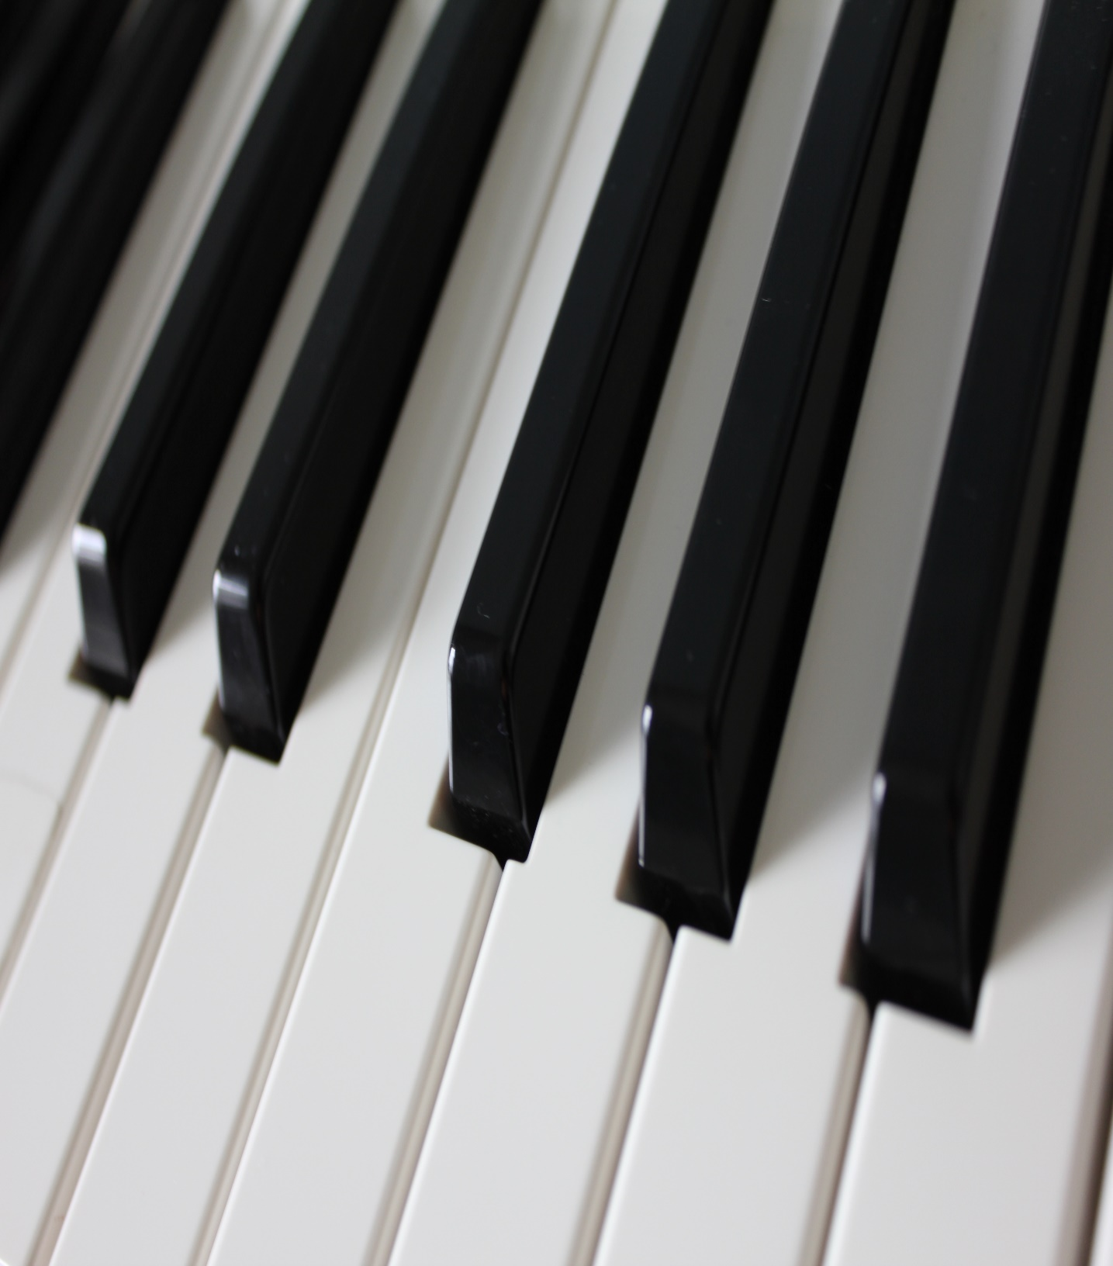

Auburn Primary School Piano Program
Limited vacancies for students in grades 1 – 6 are available.
Individual 30 minute lessons with highly qualified teachers.
Outstanding results at Auburn Primary School since 2005!
For all enquiries and enrolments please contact Rebecca Richardson
rebeccarichardson27@gmail.com
mobile: 0403 563 031

