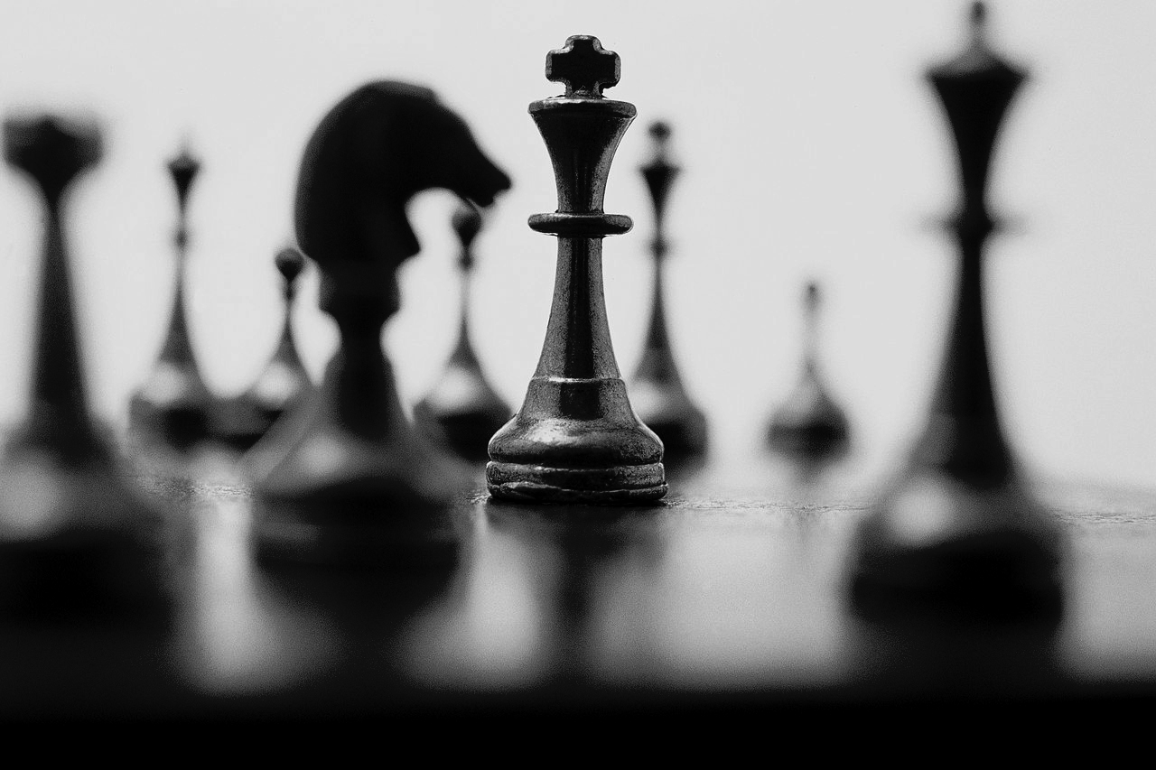
Chess Ideas

Ph: 9532 8370

Fax: 9532 8360

Mobile 0476024493

P.O. Box 3158
Ripponlea 3185
Email:
admin@chessideas.com.au

- Established in 1994

- Teaching in over 100 schools in Melbourne and Ballarat.

- Coaches to the top junior students in Victoria.

Auburn Primary School
Tuesday Lunch time 11.10 – 12.00

Term 3 Start Classes 18th July

.

Date: 18/7 – 12/9: 9 weeks

Time: Tuesday Lunch Time 11.10 – 12.00

Cost: $17.25 per lesson $155.25 for the term.

PLEASE NOTE: If chess lessons coincide with swimming or school camp, please deduct the cost of these lessons from the total amount.
Otherwise, students will not receive a refund for classes missed but students commencing after the first week do not pay for the earlier lessons.

PAYMENTS MUST BE MADE ONLINE AT: www.chessideas.com.au -
- Go to Pay Fees – Click on Term Fees
- Enter the amount from your registration form 155.25- no $ sign Add to cart.
- Next page enter all details for your child as asked:
Chess username or ID please put N/A
- Click Pay - You go to PayPal where you can pay with a PayPal account or click credit card payment at the bottom of page, no American or Diners card accepted.
All Payments need to be made by the First week of Chess

If your child has a medical condition, we should know about please advise us.

Play Chess at home against the computer.
Go to www.chessideas.com.au home page.
Click on “play chess”. It’s fun!

