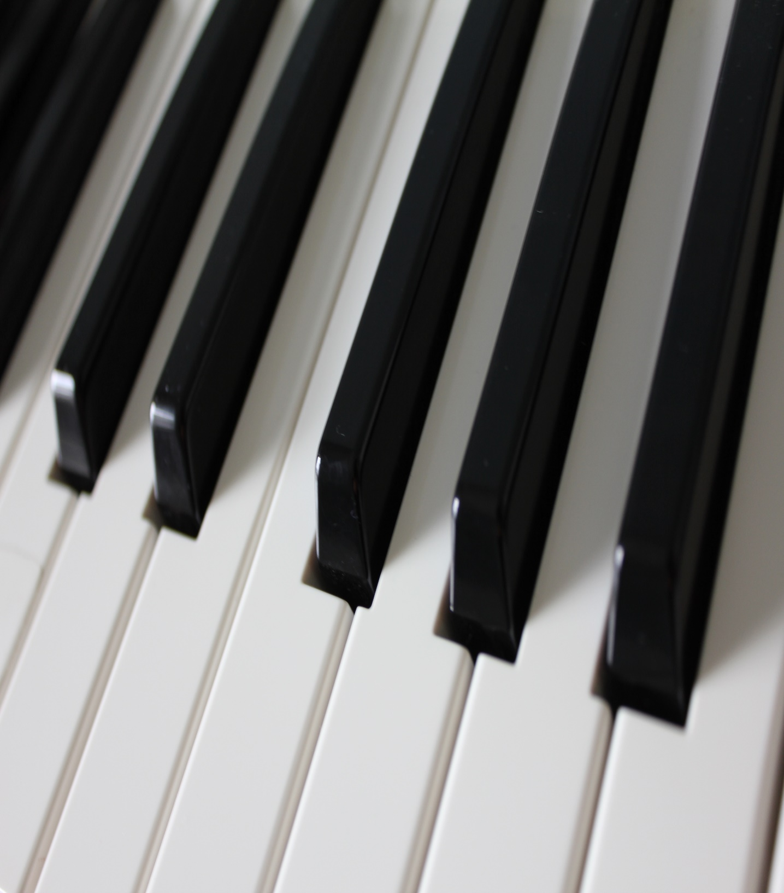

Auburn Primary School Piano Program
Limited vacancies for students in grades 1 – 6 are available in 2022
Individual 30 minute lessons with highly qualified teachers
Outstanding results since 2005
For all enquiries and enrolments please contact Rebecca Richardson
rebeccarichardson27@gmail.com
mobile: 0403 563 031

